26/4/21 🡪 Inline functions

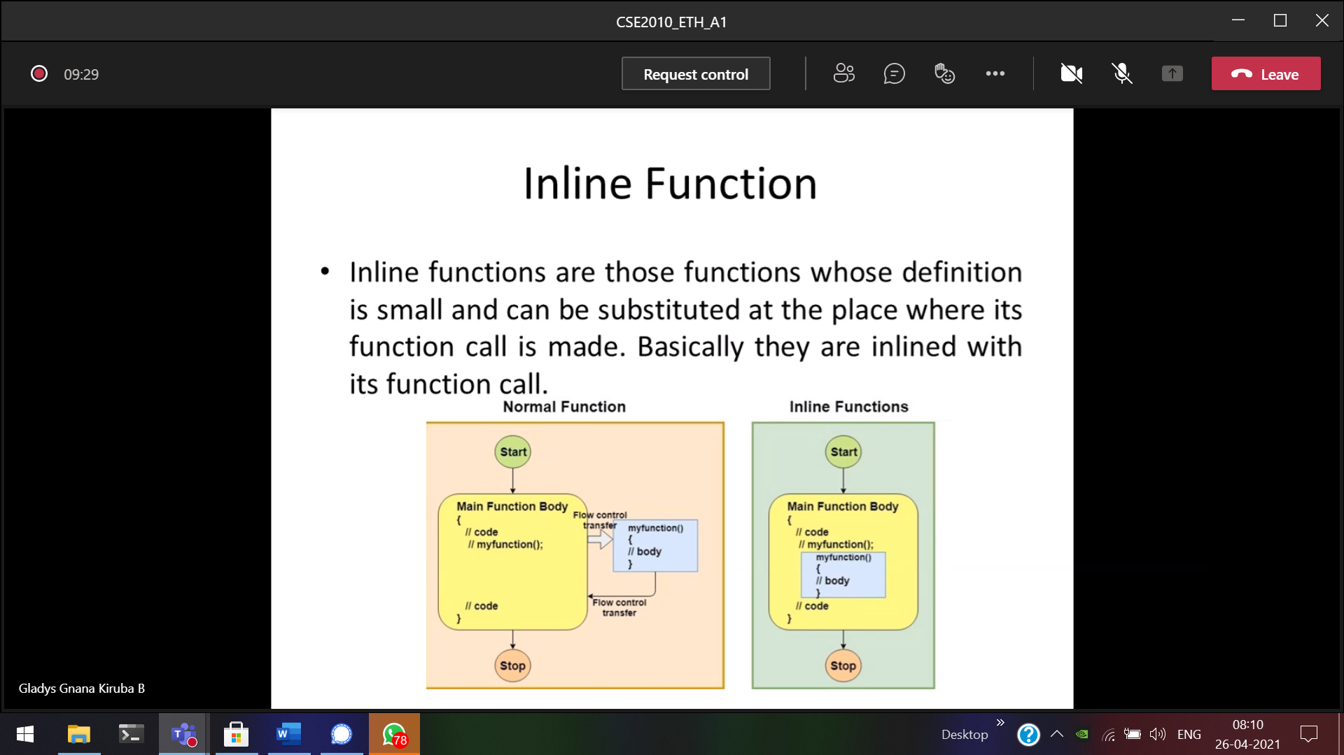

Instead of calling a small function separately and then returning to main 🡪 takes more time  
So Small functions can be included in the main()

To reduce the OS 🡪 context switch

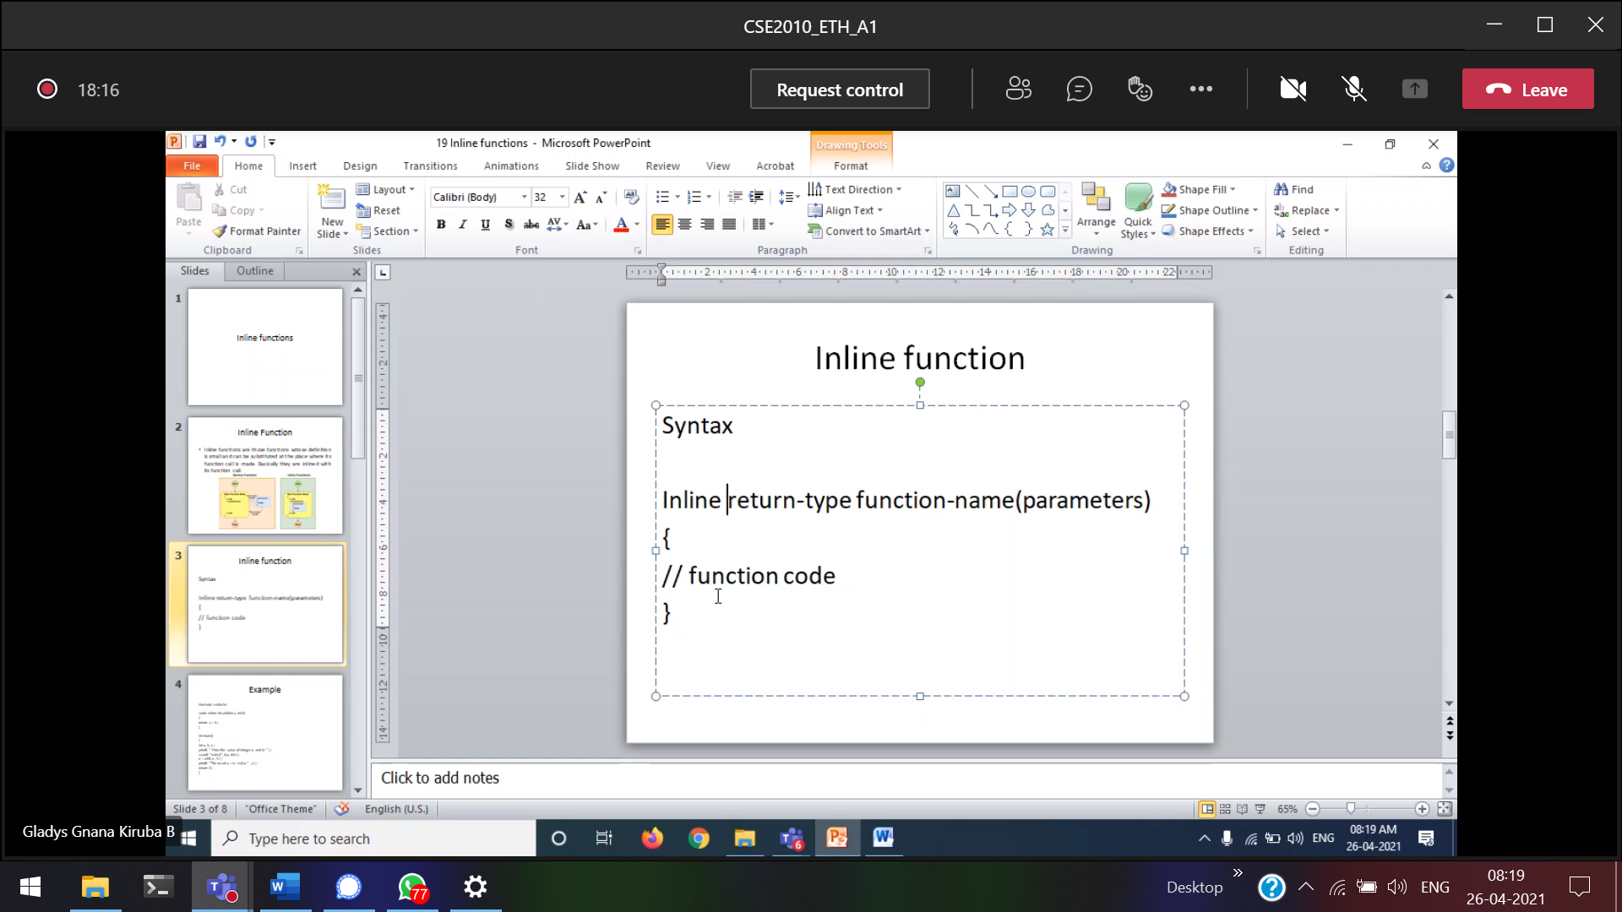

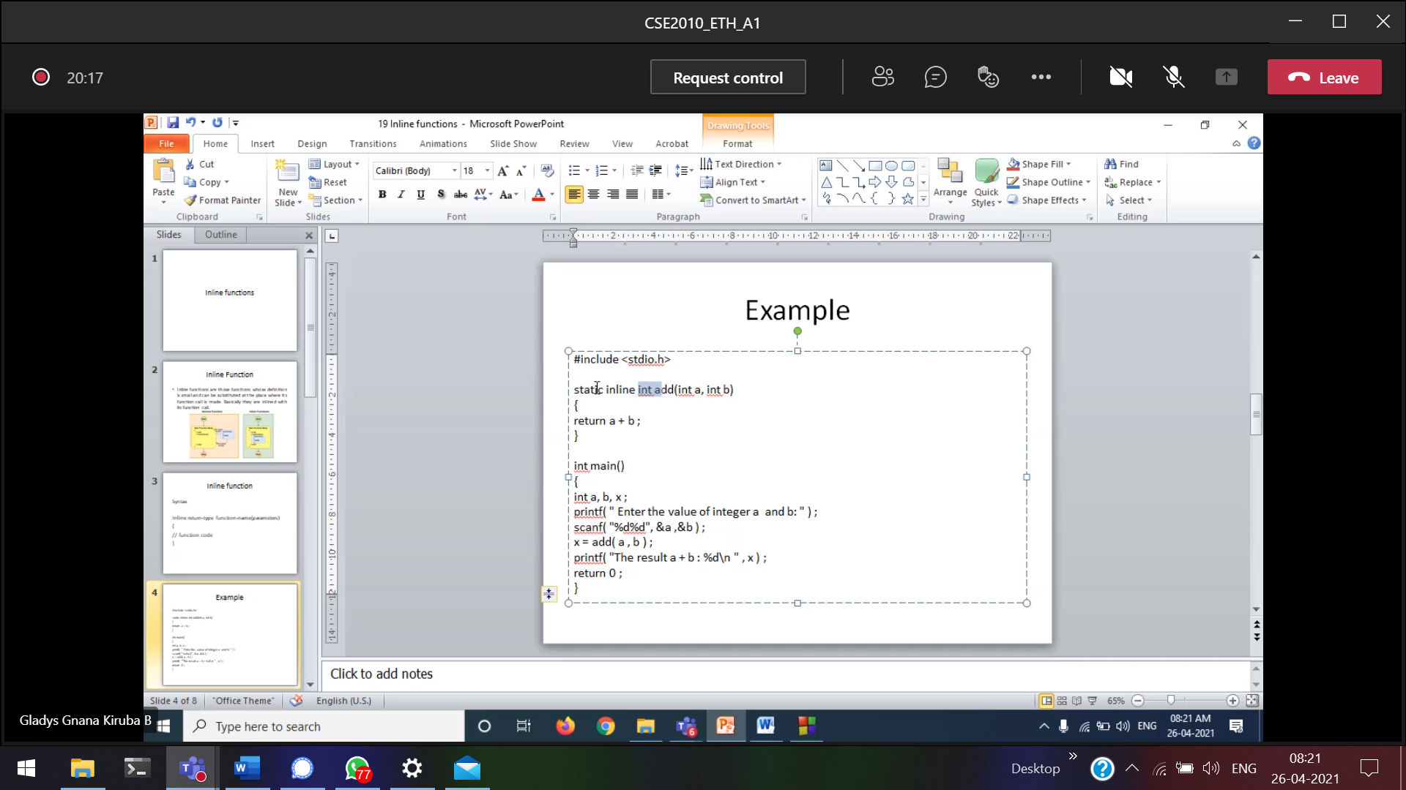

Why static ??

What is extern ??

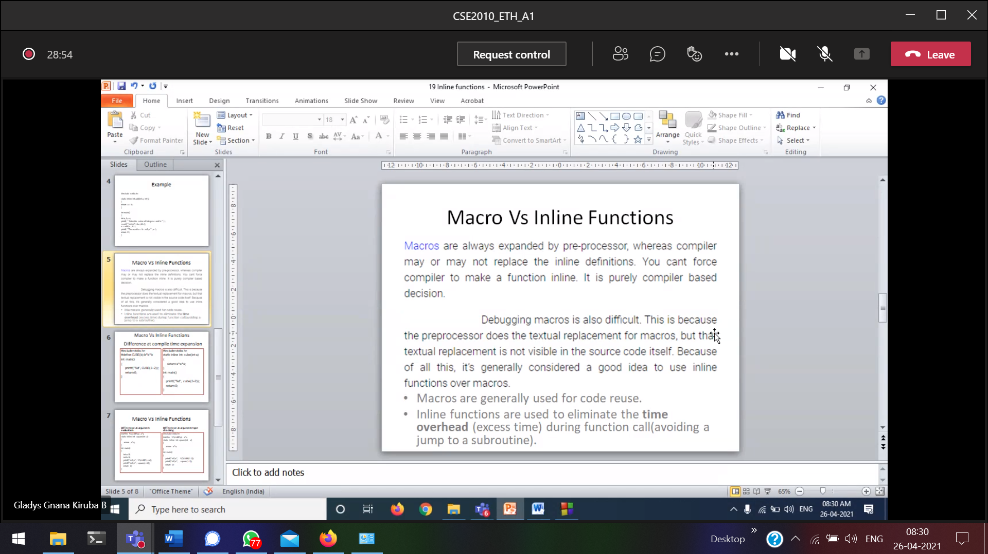

Difference between macros and inline ???

Macros will be expanded 🡪 preprocess stage

Inline will be expanded 🡪 Compiling stage

Processing time 🡪 macros faster than inline

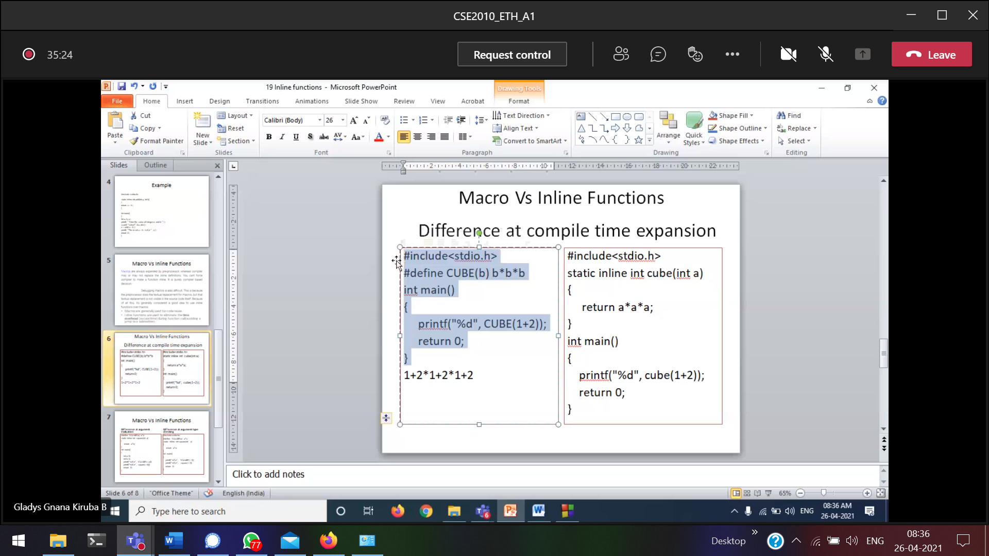

In Macros, the values will be replaced

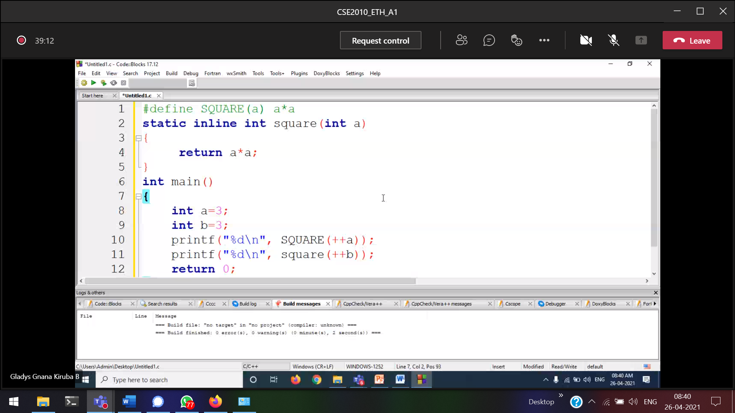

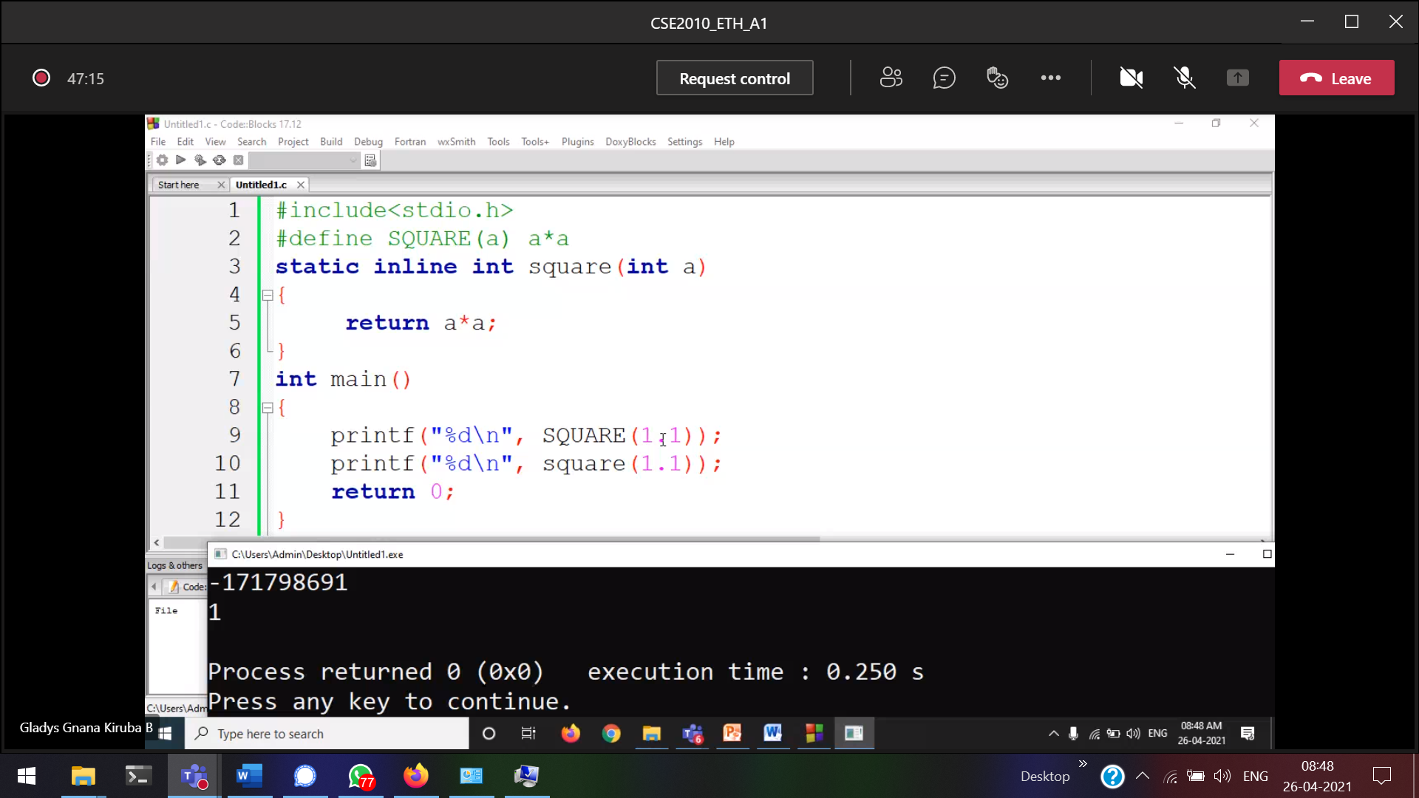

IN inline 🡪 no conditional and no looping

28/4/21 🡪 Command Line Arguments

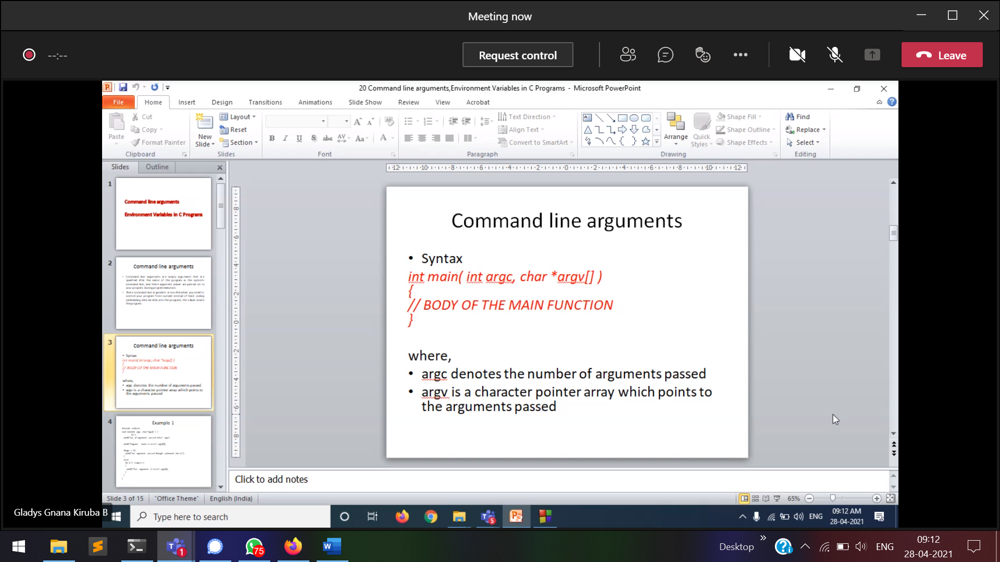

Executing the program from cmd

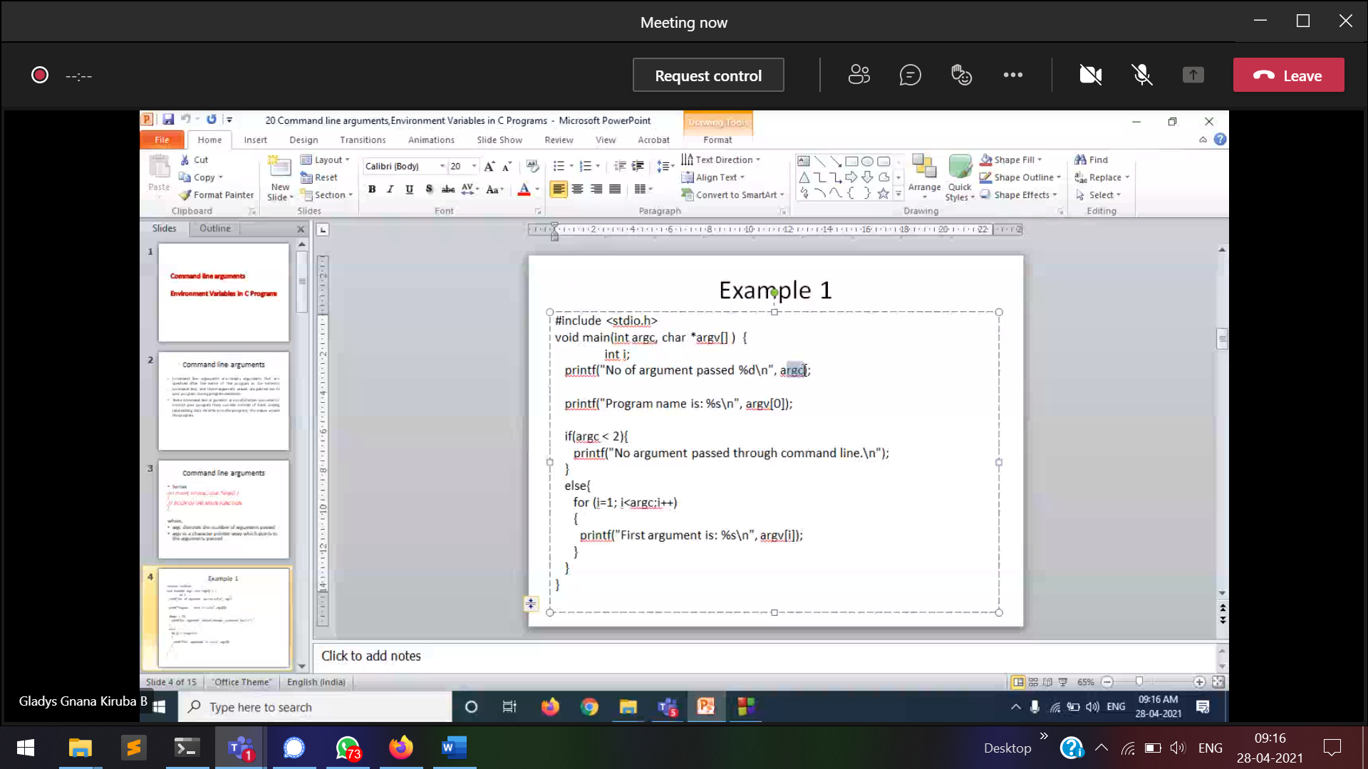

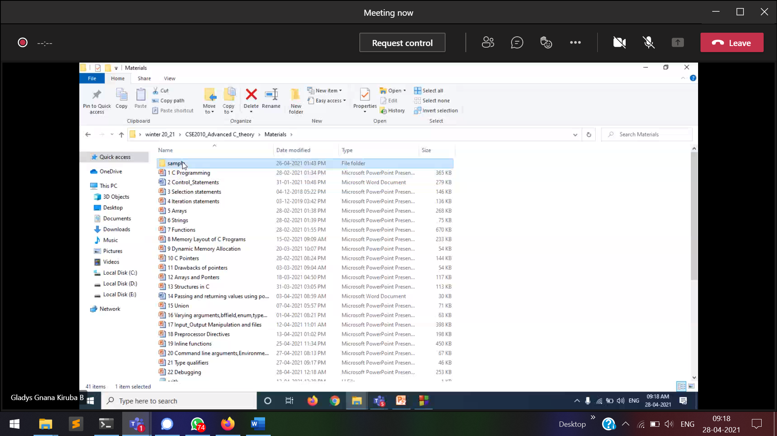

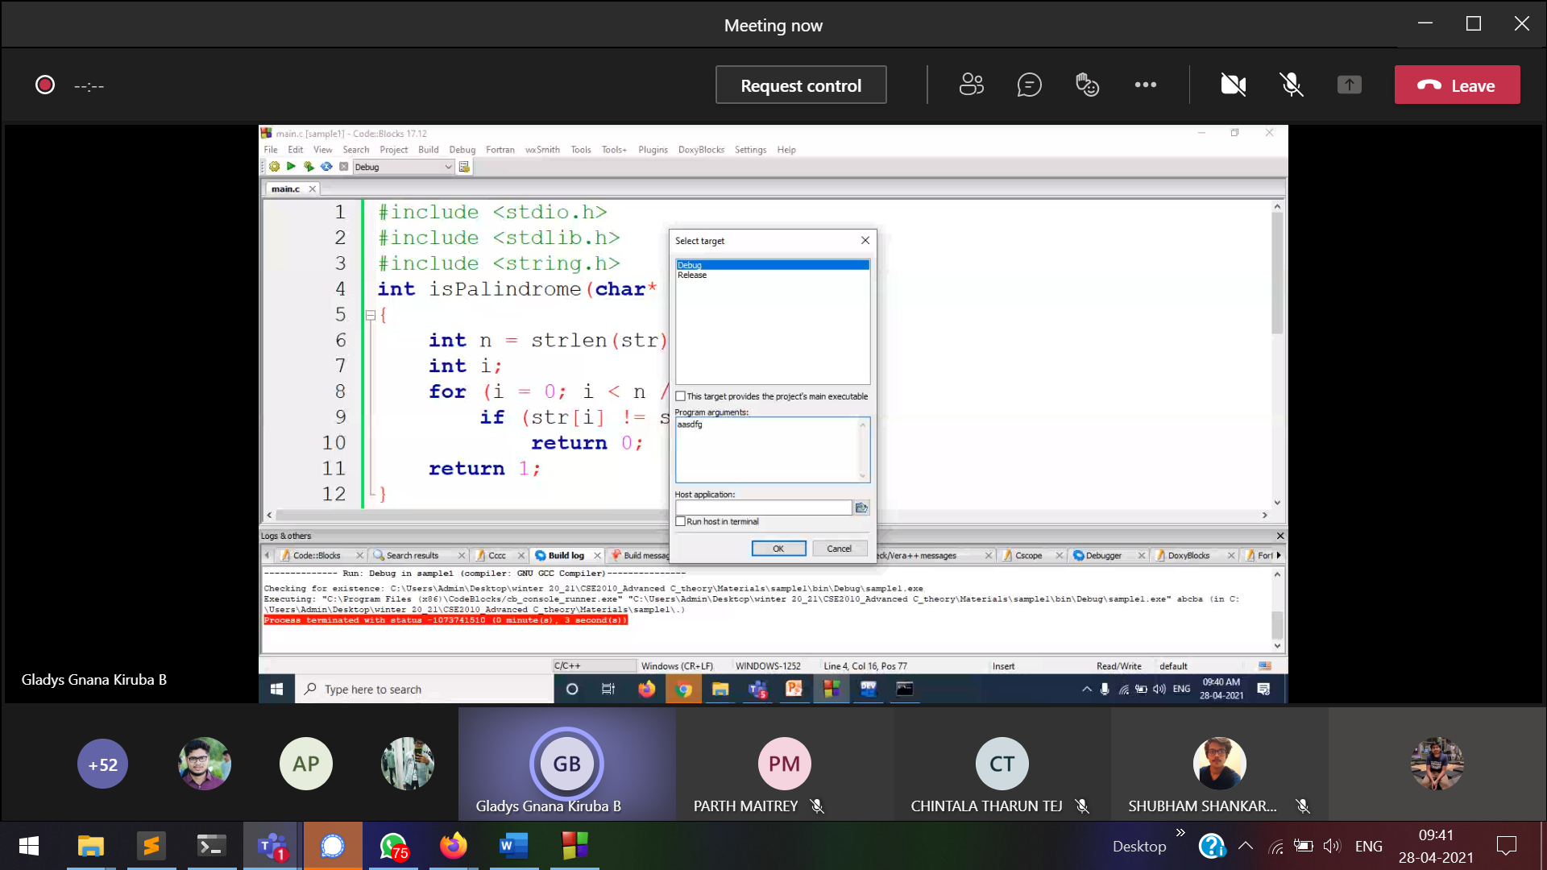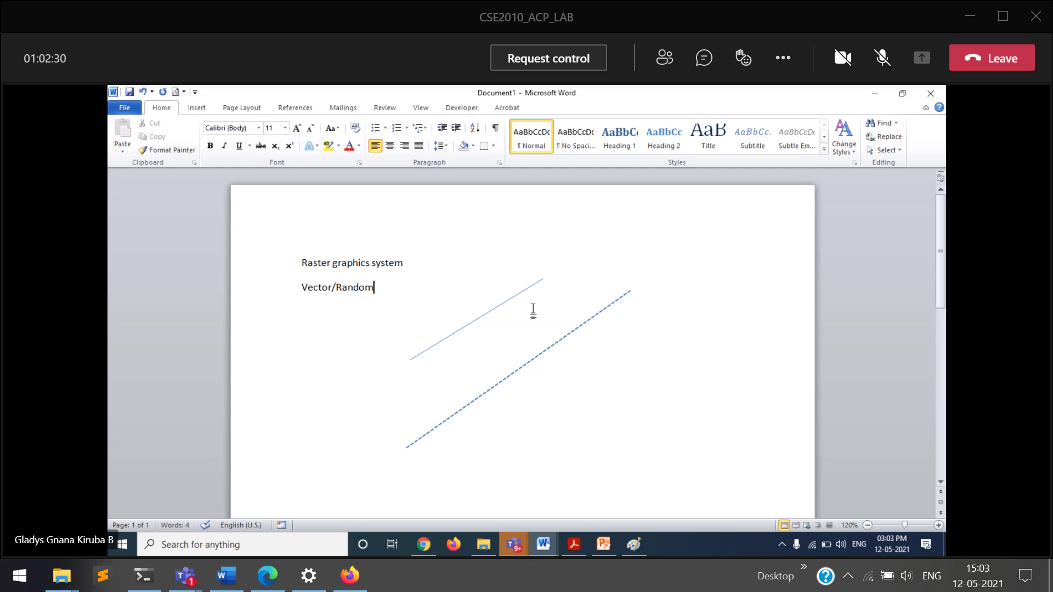

Vector /random graphics 🡪 straight line  
Raster graphics 🡪 shapes (realistic pictures)

